**OPREATING SYSTEM INSTALLATION OF SUSE LINUX ENTERPRISE SERVER**



**NAME:** Alemshet abebe **ID:** 1600882

**Installation of SUSE Linux Enterprise Server (SLES) in a Virtual Environment**

**a. Introduction**

**Background**

SUSE Linux Enterprise Server (SLES) is an enterprise-grade Linux operating system developed by SUSE, designed for mission-critical workloads such as databases, enterprise applications, and server infrastructures. It is widely used in data centers due to its stability, security, and long-term support (LTS).

Virtualization technology allows multiple operating systems to run on a single physical machine by creating isolated virtual environments. Tools such as VMware Workstation and Oracle VM VirtualBox enable users to install and test operating systems without modifying physical hardware. This approach reduces cost, improves flexibility, and supports safe experimentation.

**Motivation**

The motivation for installing SUSE Linux Enterprise Server in a virtual environment is to:

* Gain hands-on experience with an enterprise Linux server.
* Understand server-level OS installation and configuration.
* Avoid risks to physical hardware.
* Utilize a supported, stable OS with long-term support instead of outdated or unsupported systems.
* Since SUSE Linux Enterprise Server provides long-term support and enterprise hardware compatibility, it is suitable for academic and professional learning environments.

**b. Objectives**

The objectives of this installation are:

* To install SUSE Linux Enterprise Server in a virtual machine environment
* To understand the installation process of an enterprise Linux operating system
* To identify hardware and software requirements for SLES
* To gain familiarity with virtualization tools such as VMware Workstation or Oracle VM VirtualBox
* To prepare a stable server environment for future learning and practice

**c. Requirements**

**1. Hardware Requirements**

The following minimum hardware requirements are recommended for installing SUSE Linux Enterprise Server in a virtual environment:

**a, Processor (CPU):**

* 64-bit x86 processor (Intel or AMD)
* Virtualization support (Intel VT-x or AMD-V enabled)

**b, Memory (RAM):**

it is better we use half of the pc ram but minimum is 2GB

* Minimum: 2 GB
* Recommended: 4 GB or more if your pc is 8GB ram

**Note:** The system is sufficient to run a virtual machine with SUSE Linux enterprise server (recommended: 4 GB RAM, 2 CPU core, 40 GB disk

**c, Storage:**

* Minimum: 20 GB
* Recommended: 40 GB or more

**d, Display:**

* Standard VGA compatible display

**e, Network:**

* Internet connection (for updates and registration)

**2. Software Requirements**

**a. Host Operating System:**

**-** Windows 10 / 11

- Linux (Ubuntu, Fedora, etc.)

- macOS (supported by VMware)

**b. Virtualization Software (any one):**

* VMware Workstation Player / Pro
* Oracle VM VirtualBox

**Guest Operating System:**

* SUSE Linux Enterprise Server (SLES) ISO image download it from official website <www.suse.com>

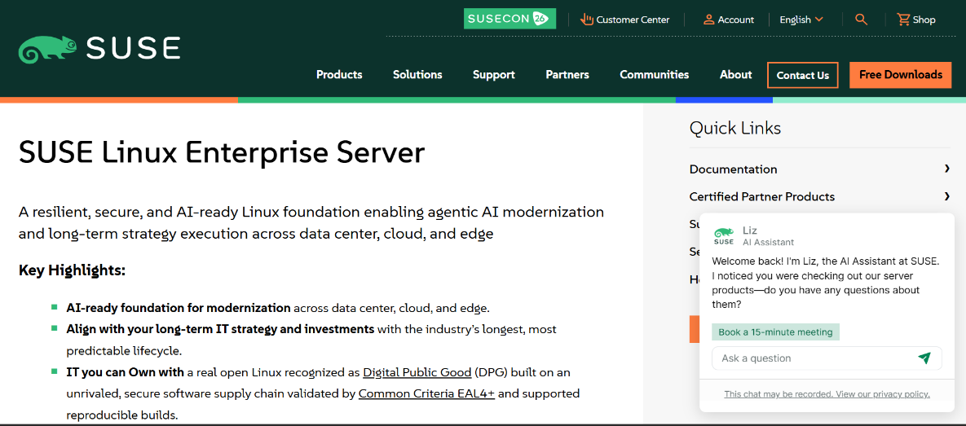

Figure 1: SUSE official download website

**Additional Software:**

* Web browser (for SUSE registration and updates)
* SUSE Customer Center account (for license activation and updates)

**Summary**

SUSE Linux Enterprise Server is a reliable, secure, and enterprise-ready operating system suitable for installation in a virtual environment. Using virtualization tools eliminates hardware risks while providing a realistic server-level learning experience. With long-term support and strong hardware compatibility, SLES meets the academic and technical requirements for modern IT education.

**Installation Steps:**

Download oracle VirtualBox from official site to install on computer

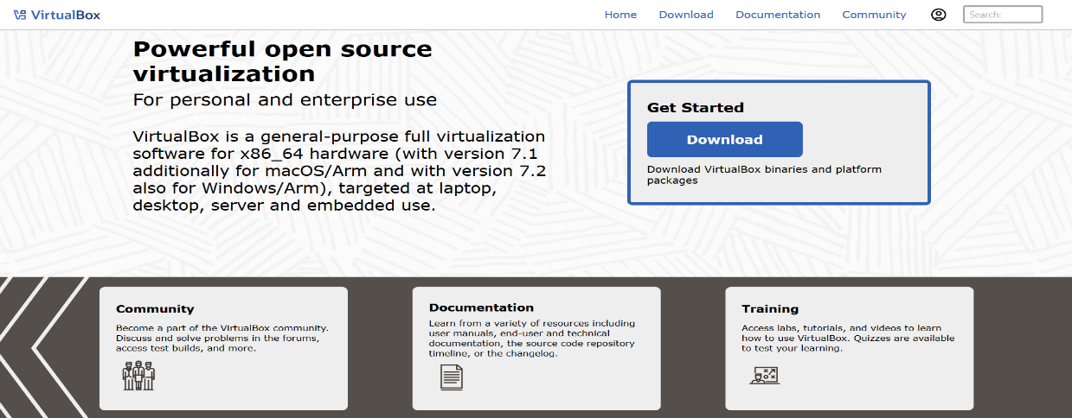

Figure 2: Oracle VirtualBox download page showing the available platform packages for installation

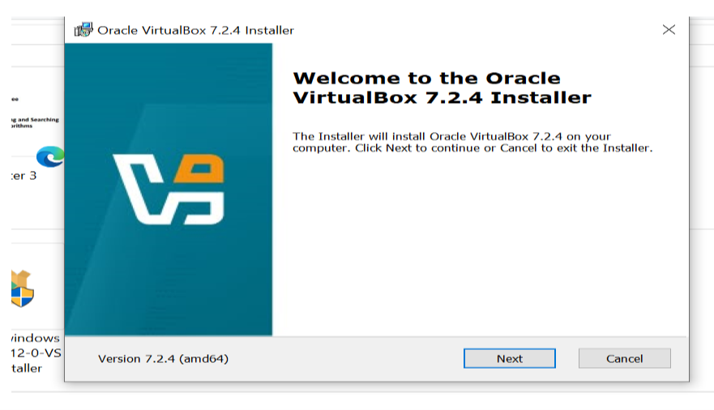

**Figure 3:** Oracle VirtualBox installation welcome screen, displayed at the start of the setup process

After launching the Oracle VirtualBox installer, the setup wizard opens with a welcome screen.

This screen confirms that the installation process has started and guides the user through the

installation steps.

**End User License Agreement**

After the welcome screen, the End User License Agreement (EULA) is displayed. This screen

presents the legal terms and conditions for using Oracle VirtualBox. The installation process can

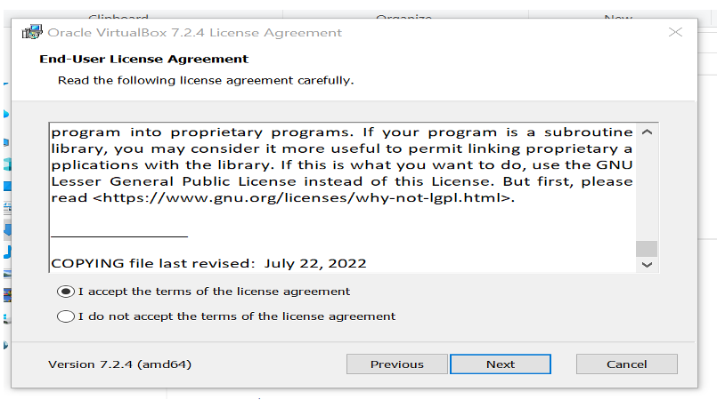continue only after accepting the license agreement

**Figure 4:** Oracle VirtualBox End User License Agreement (EULA) screen, requiring acceptance to

continue the installation

**Custom Setup**

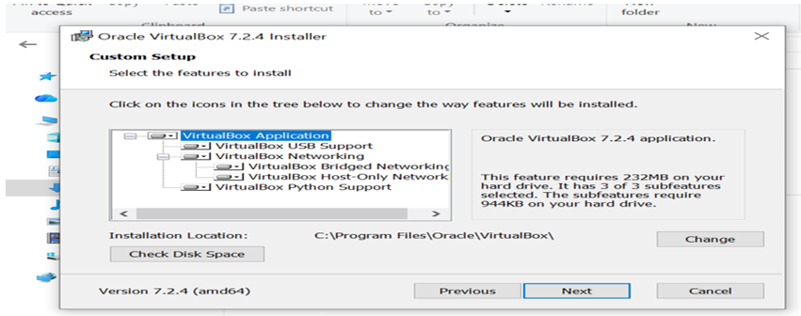

Figure 5: Oracle VirtualBox Custom Setup screen

The Custom Setup screen allows the user to review and confirm the installation location and

components of Oracle VirtualBox. In this project, the default installation settings were selected

to ensure full functionality and compatibility with the host system. No changes were made to the

default configuration.

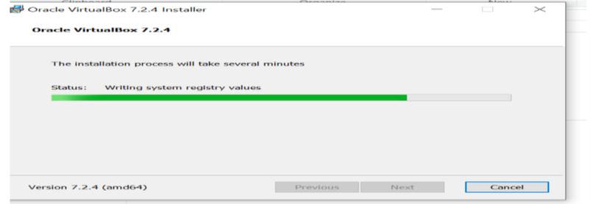

Figure 6: Oracle VirtualBox installation progress screen, showing files being copied and system

components configured

**Creating the SUSE Linux Enterprise Server Virtual Machine**

The next step is to create a virtual machine (VM)

that will host the CentOS Stream operating system. A virtual machine acts like a real computer,

allowing CentOS Stream to run inside the host system without affecting the existing operating

system.

In this project, SUSE Linux Enterprise Server 16(x86_64) is installed using Oracle VirtualBox.

Steps followed:

1. Oracle VirtualBox is launched from the desktop or Start menu

2. Click Create New Virtual Machine.

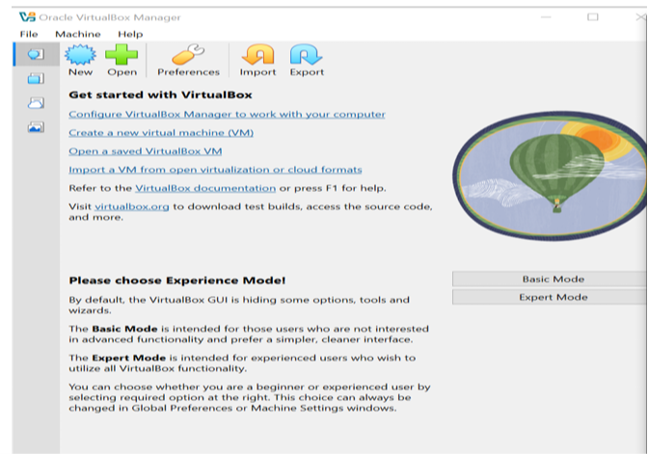

**Figure 7:** Oracle VirtualBox main interface showing the option to create a new virtual

machine

3. Choose the option to install the operating system from an ISO file.

4. Browse and select the previously downloaded Selecting the SUSE Linux Enterprise Server 16 x86_64 ISO.

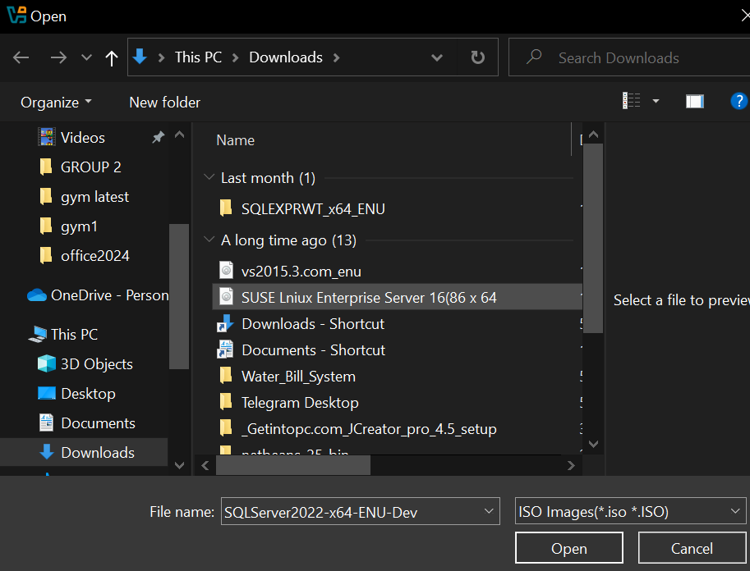

Figure 8: Selecting the SUSE Linux Enterprise Server 16 x86_64 ISO file

5. Set the operating system type as Linux.

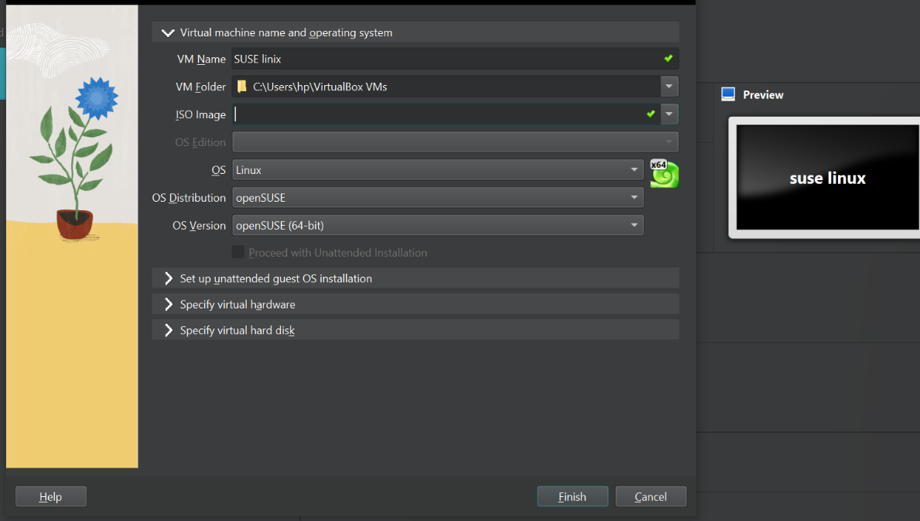

**Figure 9**: Setting the operating system

Assign system resources to the virtual machine:

o Memory (RAM): At least 2 GB

o Processor 2 CPU core

o Storage: At recommended 40 GB virtual disk space

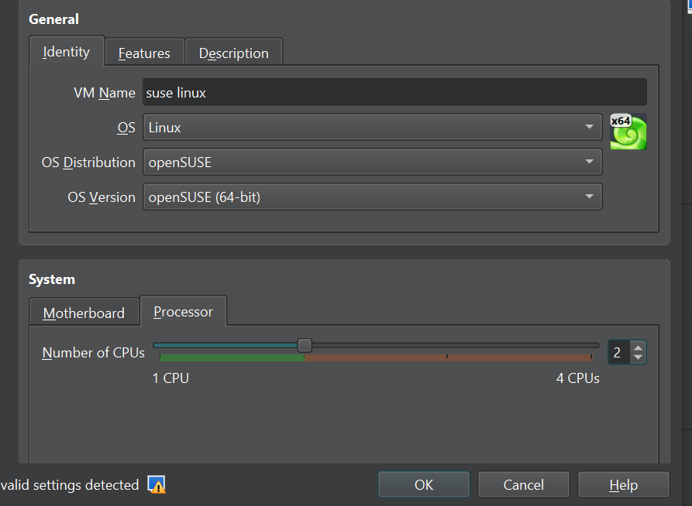

Figure 10: CPU size

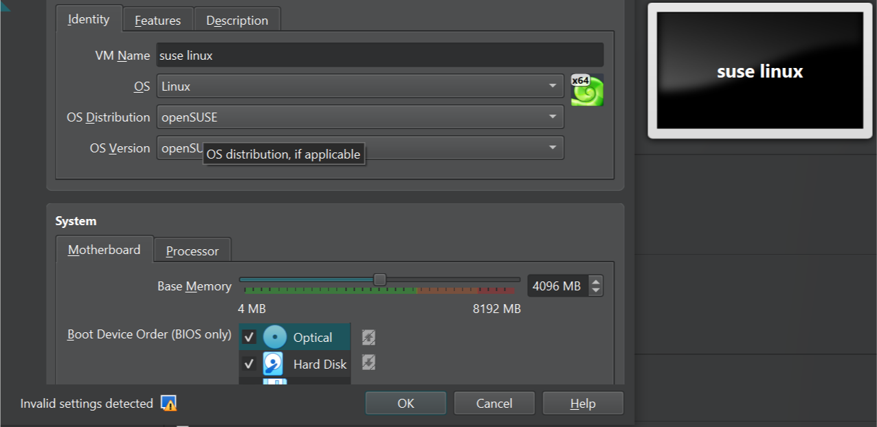

Figure 11: Base memory

The above two figures helps to Allocating system resources for the virtual machine

Disk type: VDI (VirtualBox Disk Image)

Storage: Dynamically allocated

Disk size: At least 40 GB

Then Finish the setup and save the virtual machine configuration.

Once these steps are completed, the virtual machine is ready to start the CentOS Stream 10

installation.

Start the SUSE Linux Enterprise Server Installation

After setting up the virtual machine, the next step is to boot from the ISO file and initiate the

SUSE Linux Enterprise Server 16 installation.

Procedure:

1. Open Oracle VirtualBox and select the newly created virtual machine.

2. Click Start to power on the VM.

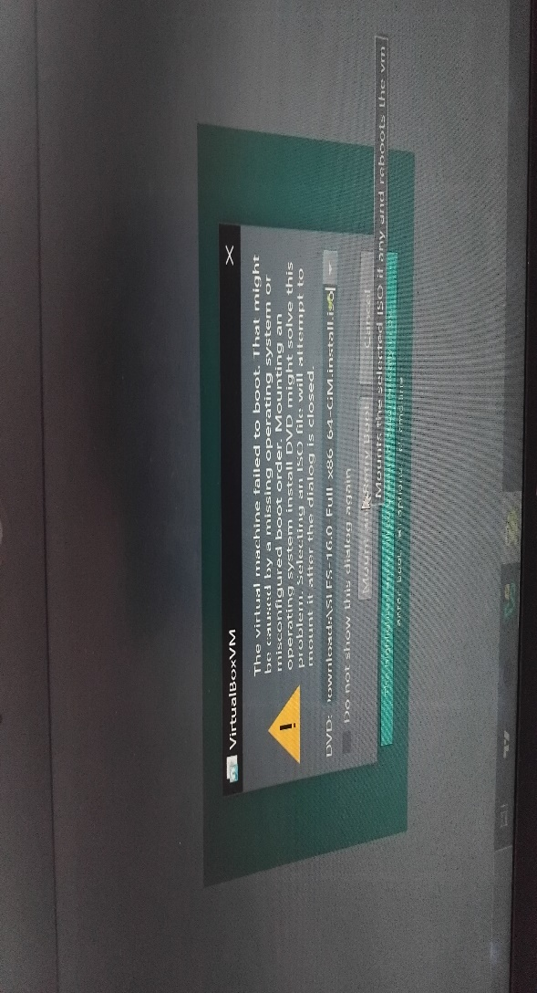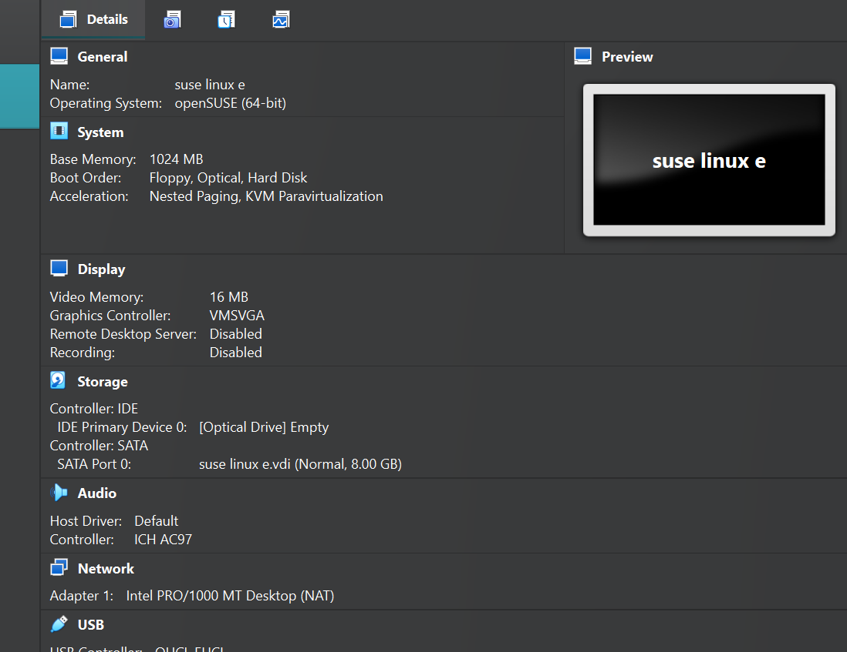

Figure 12: checking and start the newly created CentOS Stream virtual machine in Oracle

VirtualBox

Figure 13: warning of not selecting iso file

- This is normal it come only because i did not select the isol file so simply choose the suse iso and click "mount any rety boot".

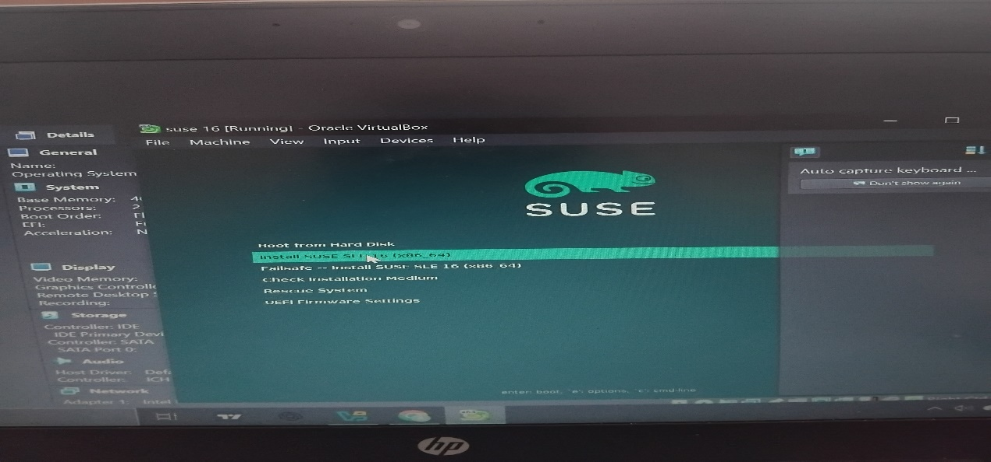

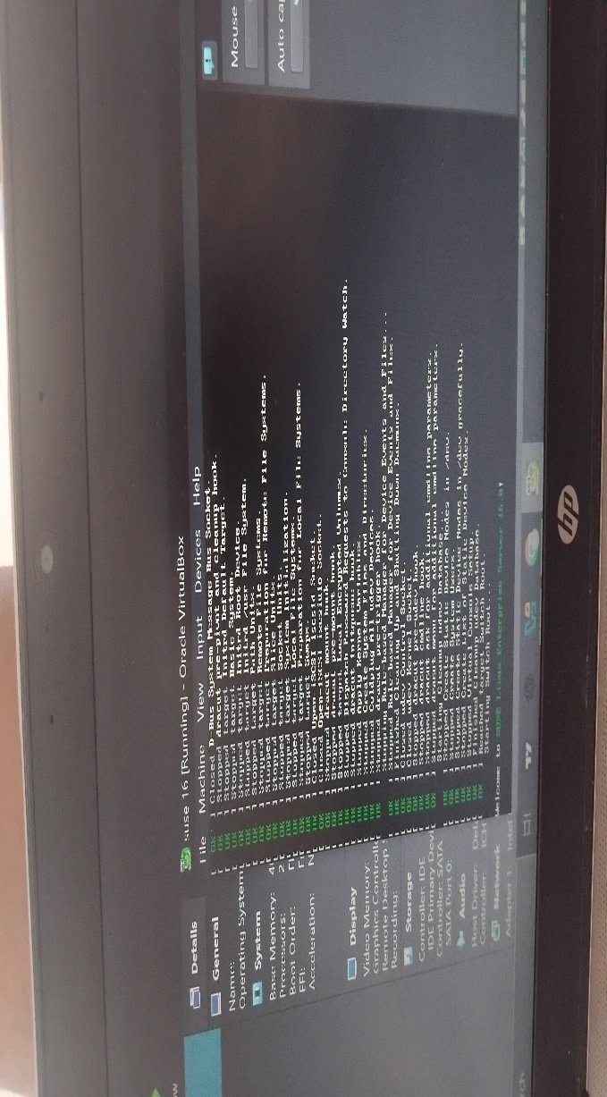

Figure 13: installation page

Like the photo shown click "install SUSE SLE 16(×86_64)"

- After that this page open:

Figure 14: processing

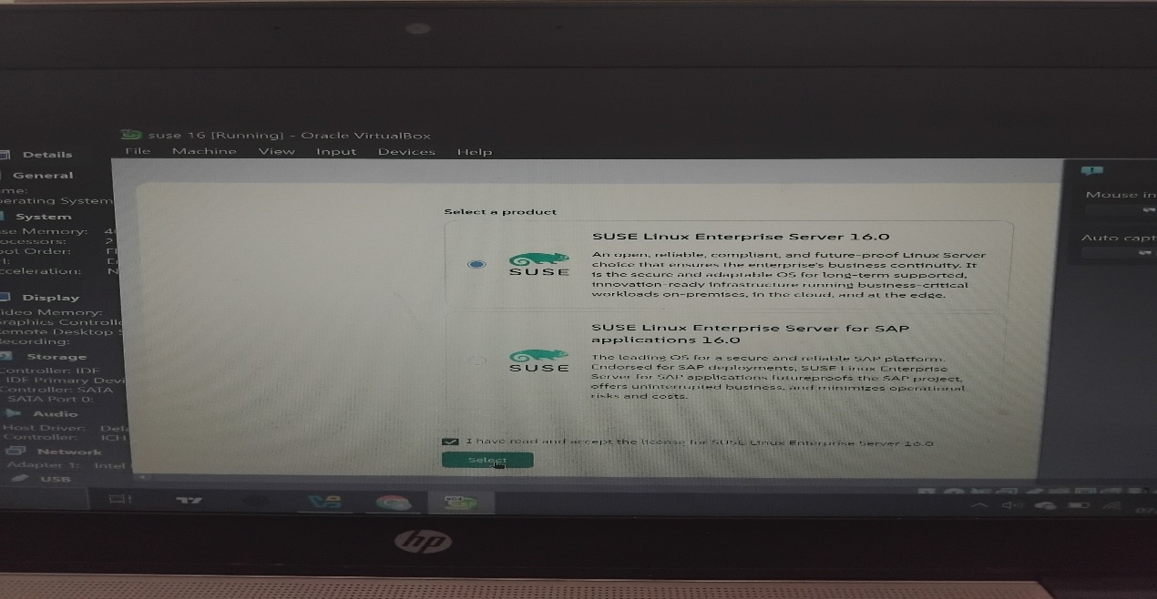

Figure 15: products

After processing product page open select the first and click "select"

The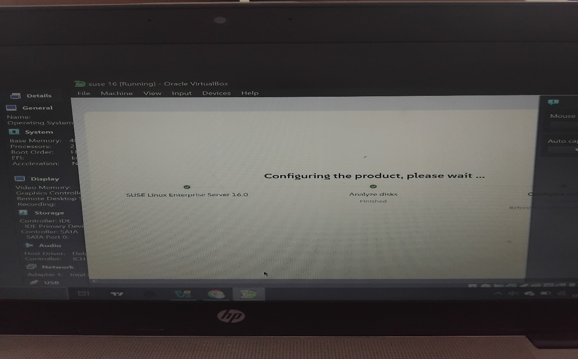n this page opened:

Figure 16: configuring

wait until configuring finish and next page open.

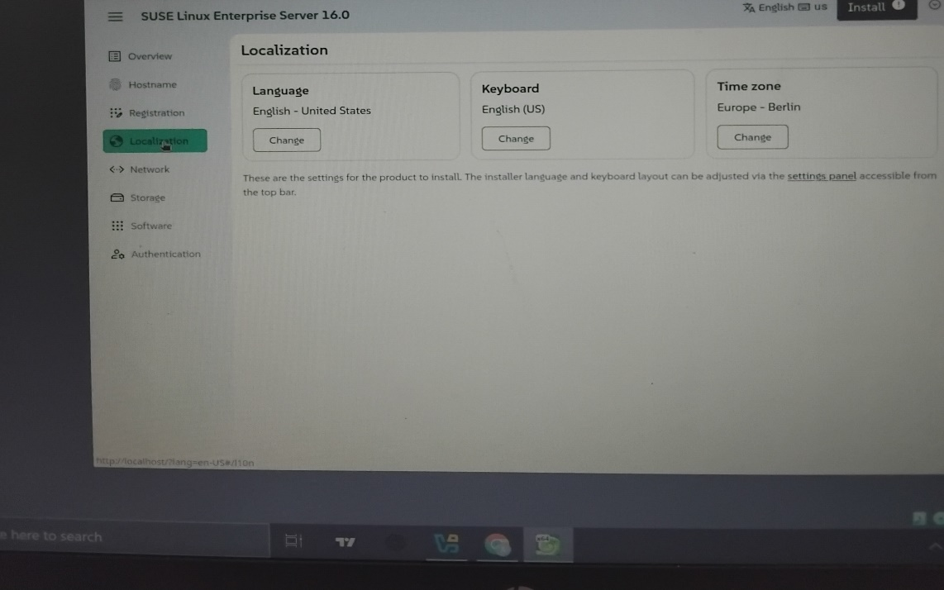

Figure 17: final installatio page

From this page select localization on the left and click time zone:

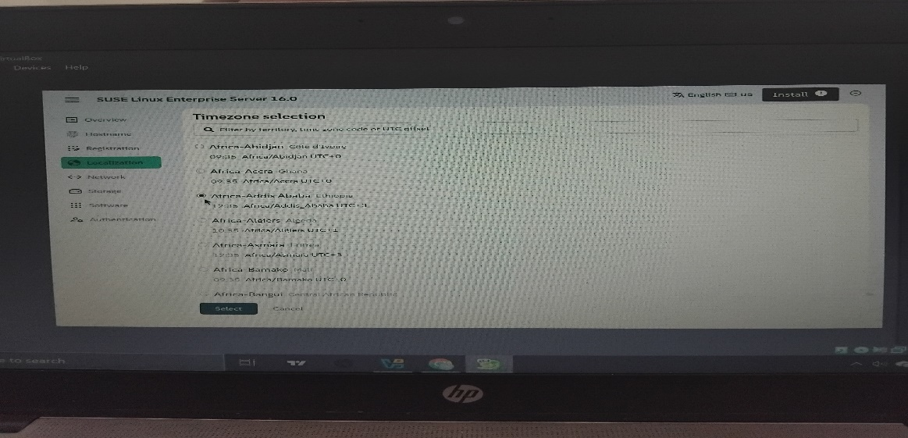

Figure 18: Localization

Then select your time zone example i choose Africa Addis Ababa/Ethiopia

Because its where i am living that is my location just like that choose your location and click select.

- Then choose authentication from the left this page will open:

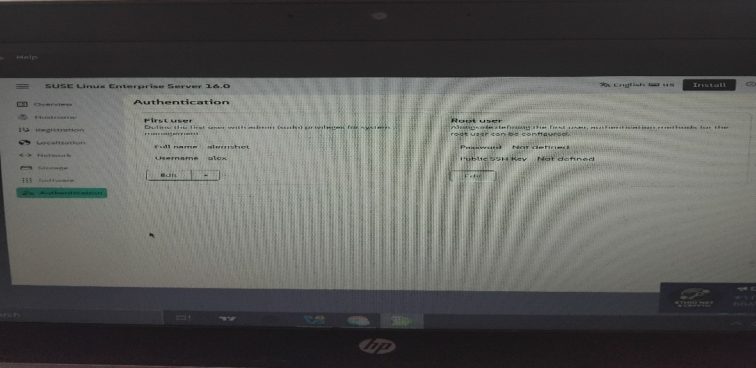

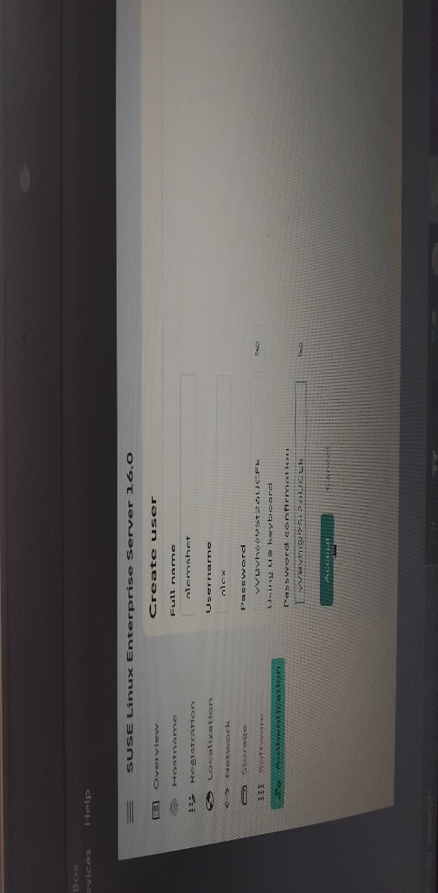

Figure 19: Authentication

In this page at "First user" click "edit" then insert your name , username, passward

Figure 20: create user

Example i write my name alemshet username alex and password after setting all this click "accept"

**Note**: this is mandatory without user you cannot install suse so you have to create a user

but you can ignore root user it is not mandatory.

Is it OK that you ignored root?

YES — this is valid and acceptable

When you:

Create a normal user

Allow that user to use sudo

Then:

- Root account still exists internally

- You can perform admin tasks using sudo

- The system works normally

Linux cannot work without root

**Root owns:**

- System files (/etc, /bin, /usr)

- Hardware control

- Boot and shutdown processes

- Even when you don’t log in as root, the system uses root internally.

**Root is a backup admin account**

If:

- Your normal user is deleted

- sudo is misconfigured

- System is damaged

**Root can**:

- Log in directly (locally or recovery mode)

- Fix the system

- Without root, recovery is very difficult.

**Security reason**

SUSE allows you to:

- Disable direct root login

- Use sudo instead

This:

- Reduces attack risk

- Prevents accidental system damage

- But root still exists behind the scenes.

**Then why does SUSE ask to set root during installation?**

Because:

- The system must have at least one administrator

- Root guarantees full access

- sudo depends on root internally

**Simple analogy**

- Root = company owner

- User with sudo = manager with permission

- You talk to the owner only when necessary

After that we can install so click "instal" at the top right corner

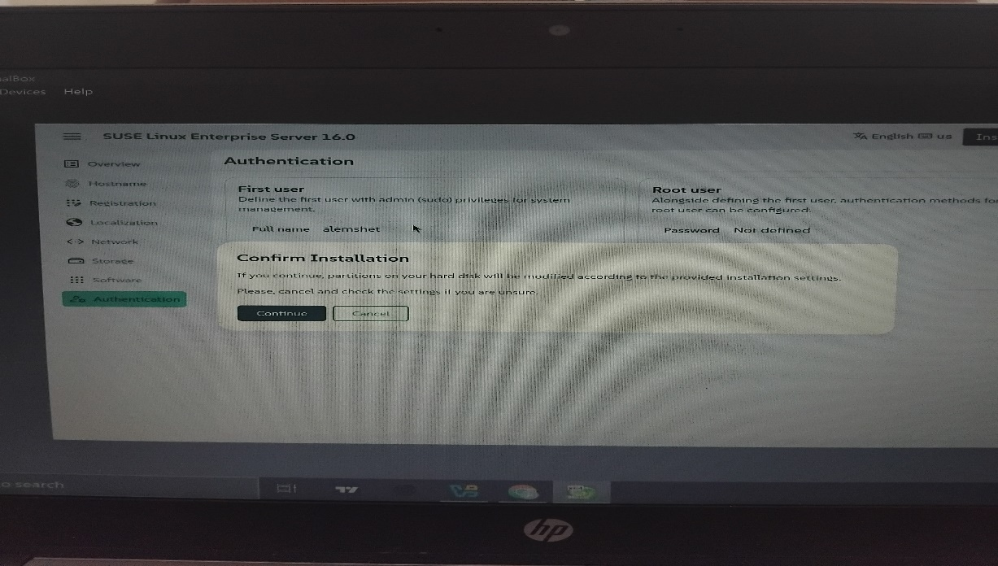

Figure 21: installation confirmation

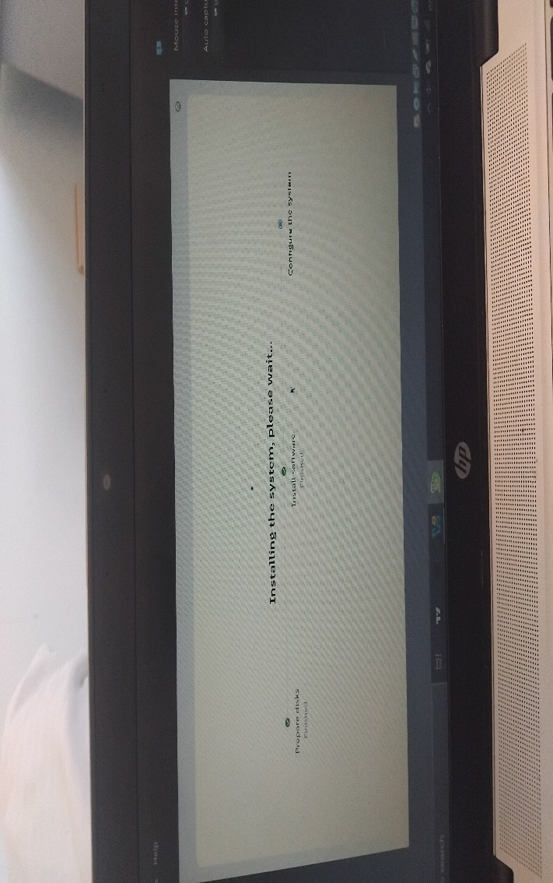then Click "continue" after this installation begin:

Figure 22: installing the system

It takes 15-20 minute to finsih so wait untill finish

Finally this page open after finished installation

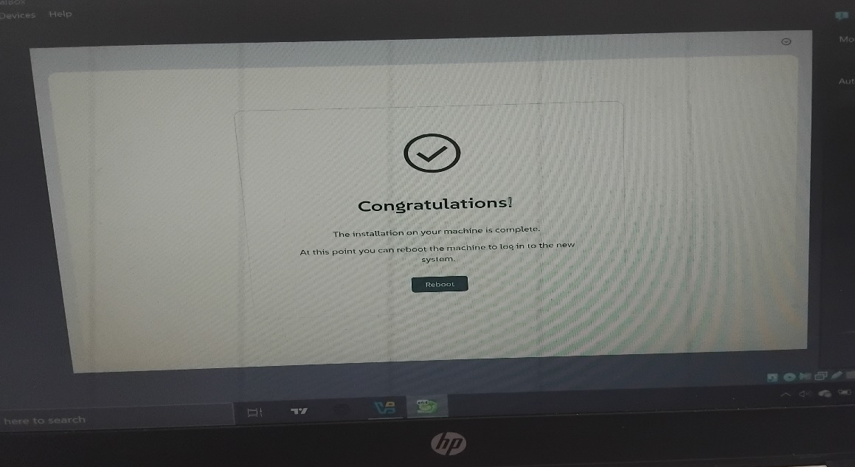

Figure 23: end of installation

Before clicking reboot

**Go to device ----> optical drive ------> Remove Disk from virtual drive**

Do not forget this step it very important if you ignore this step and simple reboot it the installation start from 0 this means the system forced to start again installation.

This is one of the problem I faced so **do not miss it!**

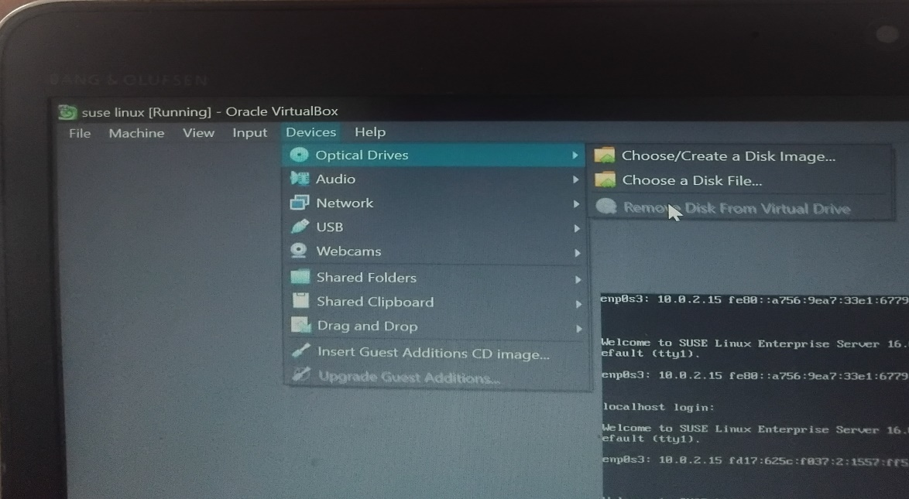

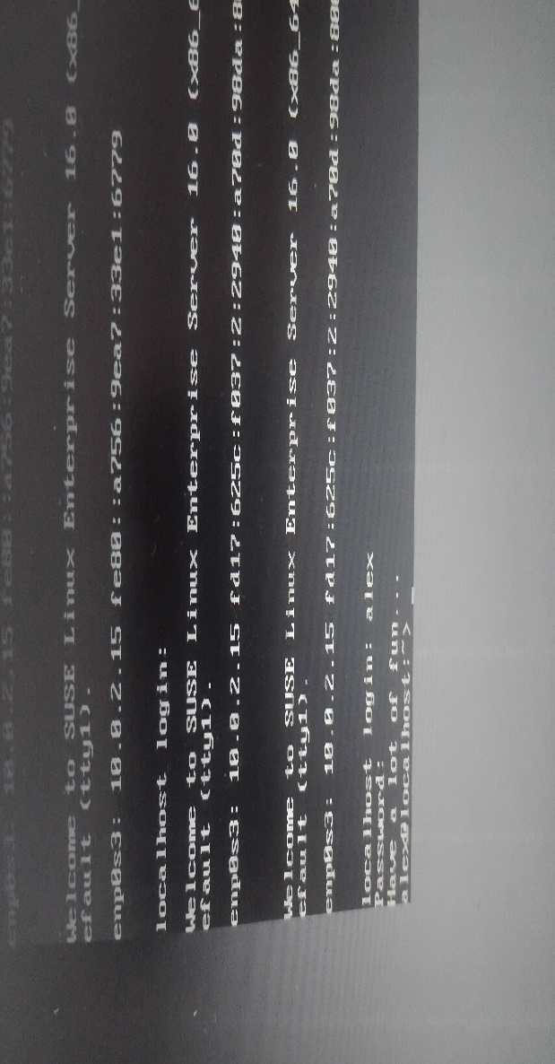

Figure 24: removing disk

After that click "Reboot" it will open it will open like

Figure 25: Text Interface (CLI / Console Mode) login page

Insert your username and password

This interface called

- Command Line Interface (CLI)

- Also called Terminal / Text mode / Console mode

What you see:

- Black screen with text

- Commands like sudo zypper install

- No windows, icons, or mouse usage

**This is the end suse linux enterprise server is installed on virtual machine**

**Issue I faced:**

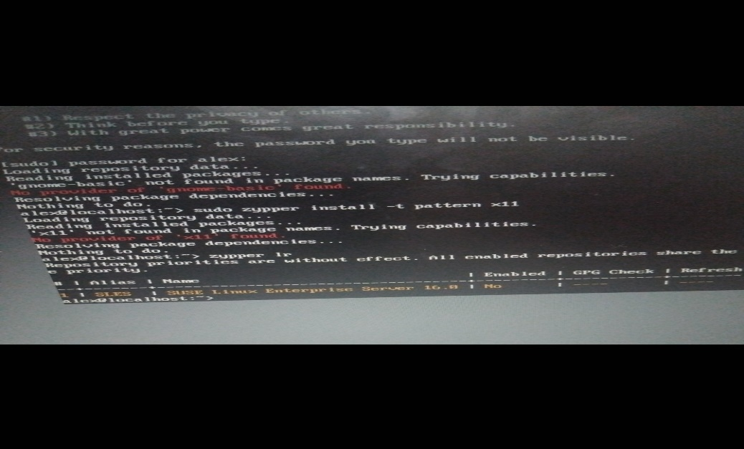

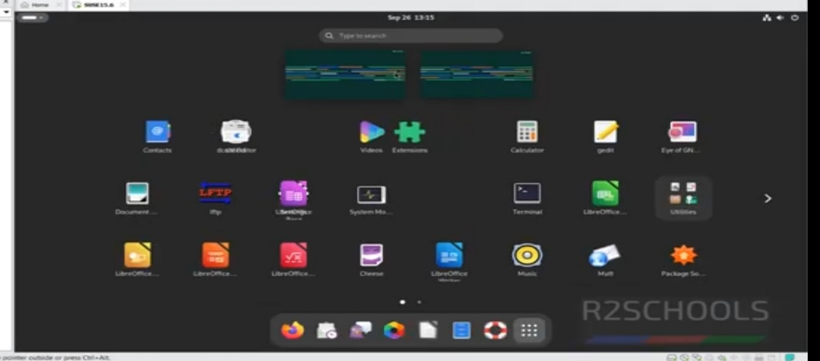

The second photo is not actually mine and it called **GRAPHICAL USER INTERFACE Specially GNOME Desktop Environment**

The problem is that Missing Graphical User Interface (GUI) due to unregistered repositories.

System opens in CLI (text mode) only not GUI mode.

The issue is that SLES is not registered, so software repositories are disabled and the GNOME graphical desktop cannot be installed.

**Solution**:

SUSE provides free SLES registration keys for students.

How:

- Create an account on SUSE / SUSE Academy

- Verify with your school or student email

- You get a valid registration key

Where can I get registration key?

SUSE Academic/University Program (Free for students)

- Some universities partner with SUSE to give students free access.

Check if your university participates:

Unfortunatlly, BDU is not partner so i cannot acess GUI Or GNOME.

**Filesystem Support in SLES**

|  |  |  |
| --- | --- | --- |
| **Filesystem** | **Supported?** | **Notes / Why** |
| ext4 | Fully supported | Default Linux filesystem. Stable, fast, journaling, widely used for system partitions. |
| Btrfs | Fully supported | Default for root in SLES 12+. Advanced features: snapshots, checksums, rollback, subvolumes. Best for enterprise use. |
| XFS | Fully supported | Good for large filesystems, high-performance storage. Often used for data disks. |
| FAT32 | Read/Write | Legacy Windows/USB drives. Limited to 4GB file size, simple format. |
| exFAT | Supported via package | Used for cross-platform USB drives (Windows/macOS/Linux). Larger file support than FAT32. |
| NTFS | Read/Write (via ntfs-3g) | Windows file system. Used if accessing Windows partitions. Not recommended for Linux system partitions. |
| ZFS | Not included by default | ZFS is optional, can be added from SUSE repositories (SUSE Open Build Service). Advanced features for enterprise storage. |
| HFS+ | Read-only by default, write limited | macOS legacy filesystem. Limited Linux support; useful for reading old mac drives. |
| APFS | Not supported natively | Apple’s new filesystem. Linux support is very limited; mostly read-only via third-party tools. |

**Advantages**

1.Safe Testing / Learning

- You can experiment with SLES without affecting your main operating system.

- Ideal for students or labs.

2. Easy Snapshots / Rollbacks

- Virtual machines allow snapshots.

- If something goes wrong, you can restore to a previous state instantly.

3. Multiple OS on One Host

- You can run Windows, Linux, and others on the same physical machine.

- Useful for cross-platform testing.

4. Portability

- VM files can be copied and run on other computers with the same virtualization software.

5. Resource Management

- You can allocate CPU, RAM, and storage specifically for the VM without touching the host OS.

**Disadvantages**

1. Performance Overhead

- VM performance is lower than running SLES directly on physical hardware.

- CPU, memory, and disk I/O are shared with the host system.

2. Limited Hardware Access

- Some hardware features (like GPUs, USB devices, or special network cards) may not work fully.

3. Disk Space Requirements

- VMs need large virtual disks for installation and snapshots.

4. Network Complexity

- Networking can be tricky (NAT, bridged, host-only modes), especially for servers.

5. Not Ideal for Production

- While fine for learning and testing, enterprise servers usually run on physical hardware for stability and performance.

**Conclusion**

Installing SUSE Linux Enterprise Server provides a stable, secure, and enterprise-ready Linux environment. When installed in a virtual environment, it allows safe testing, learning, and experimentation without affecting the host system. Registration is required to enable repositories, install the GNOME desktop, and access updates. While virtual installation is convenient and portable, it may have performance limitations compared to physical hardware. Overall, SLES installation—whether on VM or physical—offers flexibility, reliability, and a solid platform for learning Linux or running enterprise applications.

**Recommendation**

- Adopt Virtualization for Learning: Using virtual environments like VMware or VirtualBox is recommended for students and beginners to safely explore SLES features, practice system administration, and experiment with different configurations without risking the host system.

- Use Btrfs for System Stability: For future deployments, using Btrfs as the default filesystem provides advanced features like snapshots and rollback, making system maintenance and recovery easier.

- Consider OpenSUSE for Cost-Free Learning: For long-term learning or labs where registration keys are difficult to obtain, openSUSE Leap is a free alternative that provides the same tools and GUI experience.

- Enterprise Deployment on Physical Hardware: For production environments, SLES should be installed on dedicated physical servers to maximize performance, reliability, and access to enterprise-grade support.

- Keep System Updated and Registered: Always register the system with SUSE and enable repositories to ensure access to updates, security patches, and GUI packages, keeping the system secure and functional.